Day 14: 03-11-2025:

Java

JavaSE JavaEE JavaME
Standard Enterprise Micro Edition

JEE: Java Enterprise Edition
Servlet, JSP and EJB
Using JEE we can create Enterprise Application or Web application.

Using JSE we can create console base application or desktop application.
Java OOPS concept, collection, exception handling,
AWT or swing or JavaFX ( GUI interface).
JDBC
MySQL or Mongo DB

Limitation of standalone or desktop
- Only one user can access.
- Every machine we need to install that software.
- If we do any changes in features we need to update every machine mandatory.

Web Application : JEE

http://www.google.com - URL : Uniform resource locator.

http/https------------ req

Client Server

Res--------http/https html
Css and bootstrap
JS
JavaScript

Server side technologies
JEE
Servlet, JSP and EJB

Java Frameworks
Struts
JSF
Spring framework and Spring boot

Asp.net
Php
Python with Django/Flask
Node with Express JS

To deploy or run server side application we need server.
Application point of view server mainly divided into 2 types.
- Web server :tomcat
- Application server : web logic, jboss, etc.

JEE : In Servlet, JSP and EJB no main method. We need compile the program and deploy or run program in server environment.
Server contains container, container is also know as run time environment for web modules. If server is a type of web server which contains web container. This container is responsible to run servlet and jsp program. If server is application server which contains more than one web container, ejb container, jms container. Which provide extra features like connection pooling, thread management, resource management, security etc.

Servlet : Servlet is normal java program which help to create dynamic web page on server.

Servlet API :

servlet : servlet is a package.
Servlet :
import javax.servlet.*;
Servlet is an interface which contains set of methods.
init, service, destroy, getServletInfo, getServletConfig etc.

1st approach
Class MyServlet implements Servlet {
Need to provide the body for all 5 methods.
}
GenericServlet : it is a type of abstract class which internally implements Servlet interface and provided body for 4 methods except service method.
2nd approach
Class MyServlet extends GenericServlet {
Need to provide the body for only servlet
}
HttpServlet : it is a type of abstract class which internally extends GenericServlet and provided body for service method and provided extra method in the form of doXXX like doGet, doPost, doPut,doDelete etc.

3rd
Class MyServlet extends HttpServlet {
Override doGet or doPost etc.
}

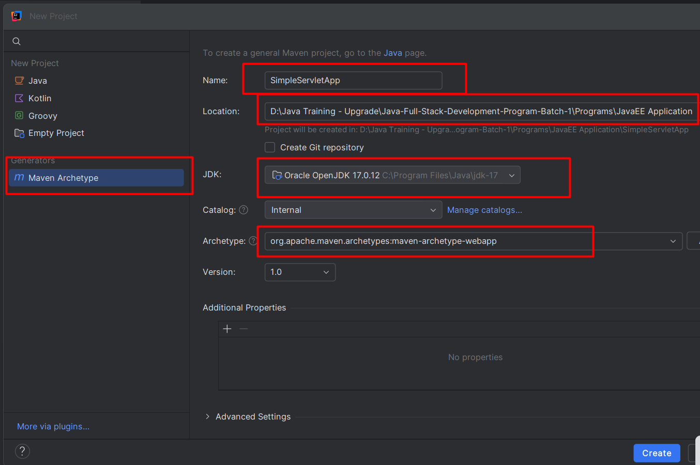

Tomcat-servers.xml

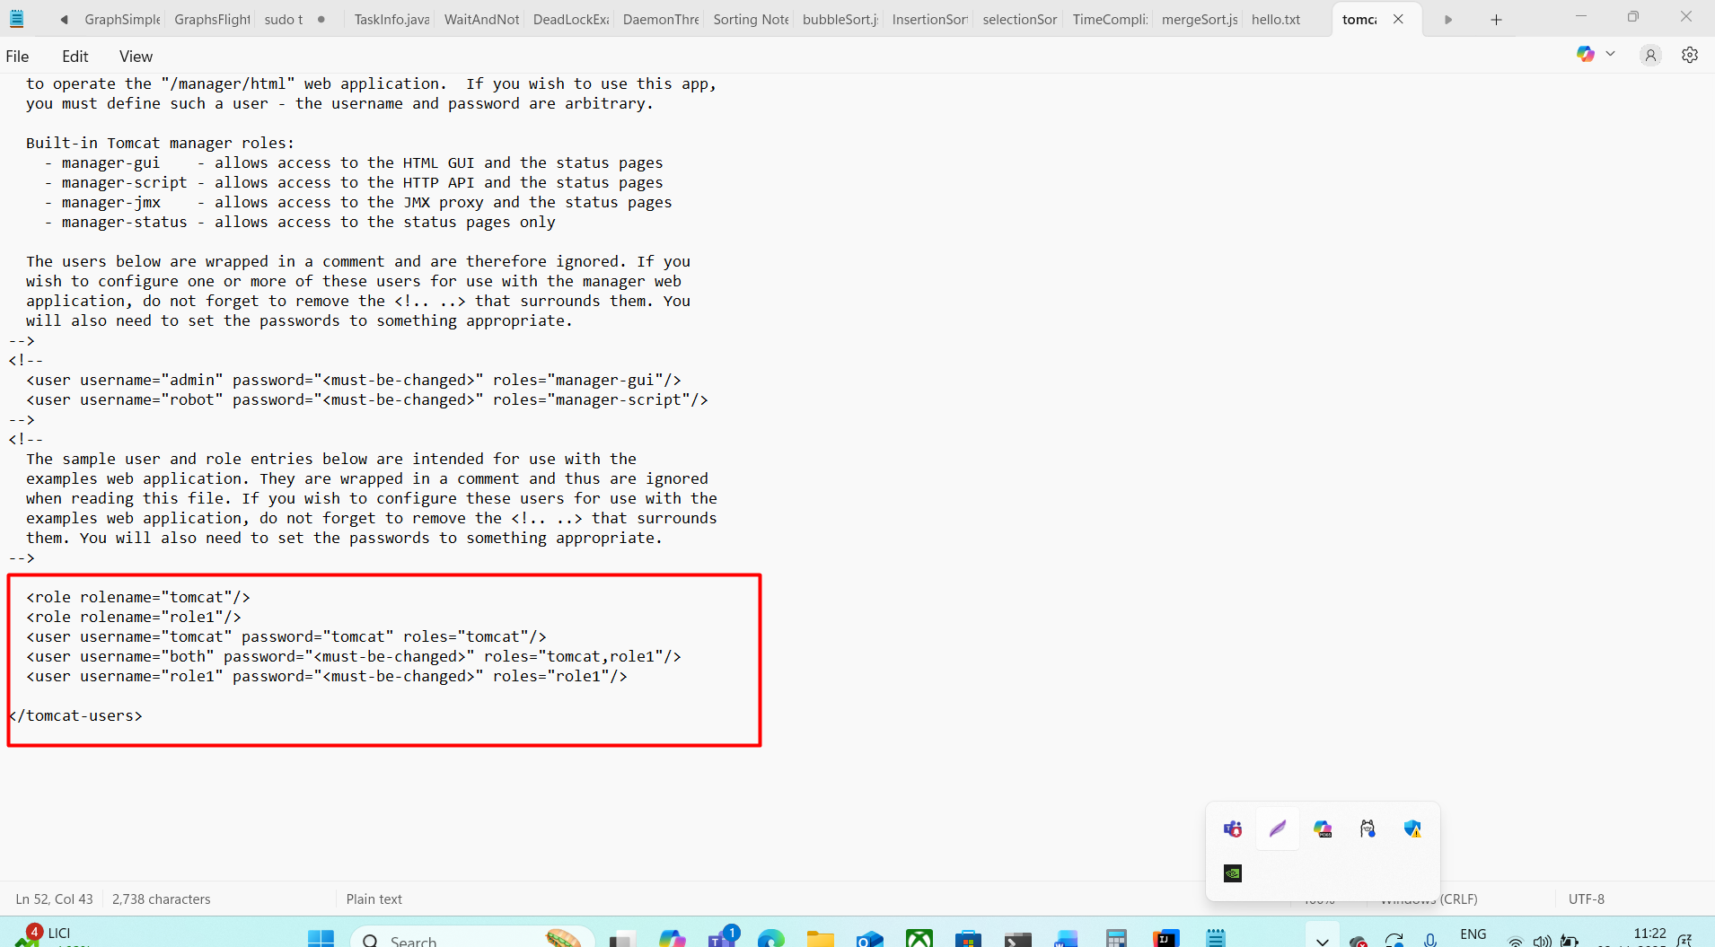

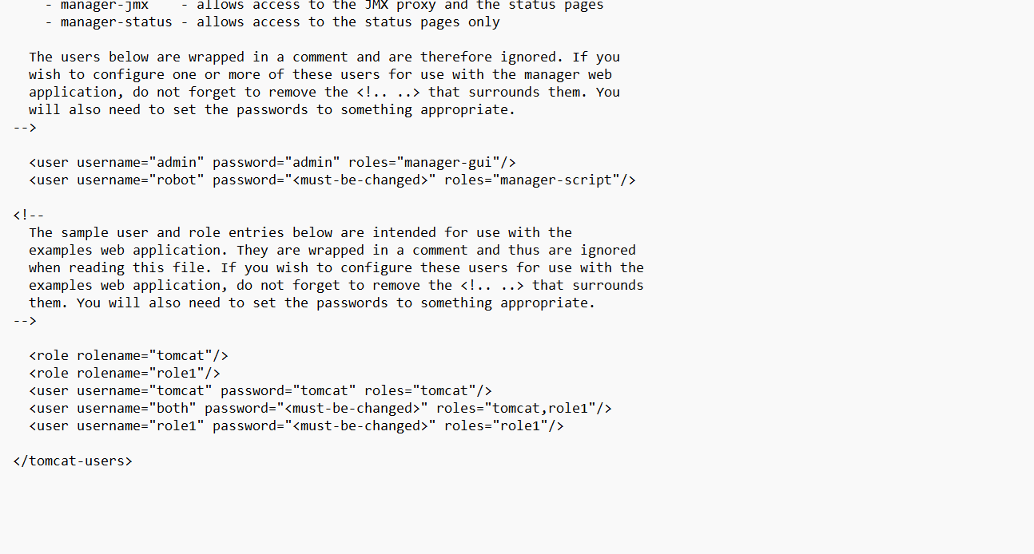

To run the tomcat open command prompt inside bin directory and run the command as
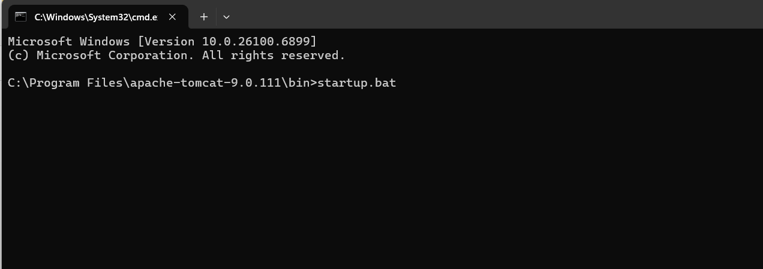

Simple Servlet Program
package com;
import javax.servlet.ServletException;
import javax.servlet.http.HttpServlet;
import javax.servlet.http.HttpServletRequest;
import javax.servlet.http.HttpServletResponse;
import java.io.IOException;
import java.io.PrintWriter;
public class MyServlet extends HttpServlet {
@Override
protected void doGet(HttpServletRequest req, HttpServletResponse resp) throws ServletException, IOException {
//super.doGet(req, resp);
System.out.println("MyServlet doGet");
PrintWriter pw = resp.getWriter();
pw.println("<html><body><h1>MyServlet</h1></body></html>");
}
@Override
protected void doPost(HttpServletRequest req, HttpServletResponse resp) throws ServletException, IOException {
//super.doPost(req, resp);
}
}

Client application or browser can’t call servlet program directly. We need to do configuration in web.xml file or using annotation.

Navigation from one servlet page to another servlet page.
RequestDispatcher : it is an interface which provided set of methods which help to navigate from one servlet page to another servlet page.

RequestDispatcher rd= request.getRequestServlet(“path”);

Target page is servlet then we need to provide URL pattern. If target page is jsp or html we need to provide html or jsp page name dot extension.
rd.include(request,response); currentPage + targetPage output combine as one page
or
rd.forward(request,response); we can view the output of only target page.

Login table in mysql database
Emaild is PK and password is not key attribute

Index.html -login page.

SignUp.html - signup page

LoginSignIn - Servlet
Inside doPost method receive the value from index.html page and with help of jdbc check emailed and password if correct page Home servlet page. Else display error and include same index.html page.
LoginSignUp Servlet

Inside doPost
Receive emailed and password and using jdbc create the account. And with help request dispatcher include LoginSignUp.html page.

